  
ESCUELA SUPERIOR   
PÓLITECNICA DEL LITORAL  
  
**WORKSHOP OF   
CODING STANDARDS**  
  
**AUTORES:**

* AGUILAR MORA OSWALDO
* BERMUDEZ MOREIRA KAREN
* BERNAL MOREIRA GUILLERMO
* ORTIZ HOLGUIN EDUARDO
* WONG PAVON HUGO

**SUBJECT:** ING. SOFTWARE II  
**TUTOR:** DR. MERA CARLOS  
**DEADLINE:** 2020/06/11

1. **Abstract**

This document contains the technical report corresponding to the first group workshop called **"WORKSHOP OF CODING STANDARDS"** of **GROUP#4** belonging to the **SOFTWARE II ENGINEERING** course of **2020-PAO I**.

The report contains a description of the workshop, the code, the JAVA implementation and the checklist reports.

1. **Description**

Checkstyle is an open source tool that enforces coding conventions and best practice rules for Java code. It automates the process of checking Java code to spare humans of this boring (but important) task. This makes it ideal for projects that want to enforce a coding standard.

Checkstyle can check many aspects of your source code. It can find class design problems,

method design problems. It also can check code layout, formatting issues and generate projectwide reports that summarize the breaches found. Checkstyle provides many checks that you can apply to your source code:

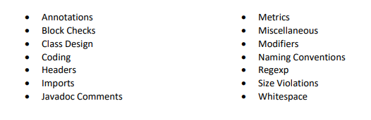

There are several ways to use this tool, including the command line and build automation tools. In this lab, Eclipse will be used in conjunction with Maven to facilitate the use of Checkstyle.

1. **Activity Screenshots**
   1. **Part 1: Install Maven for Eclipse.**

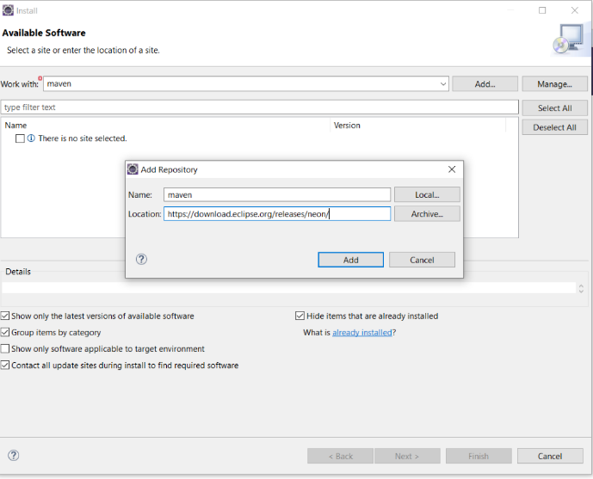

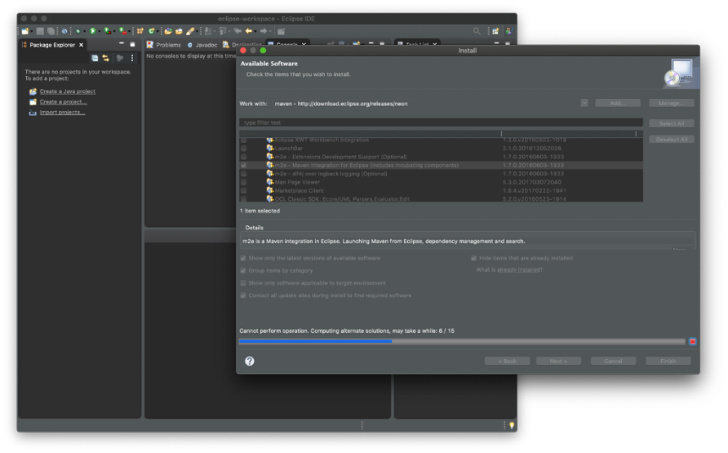

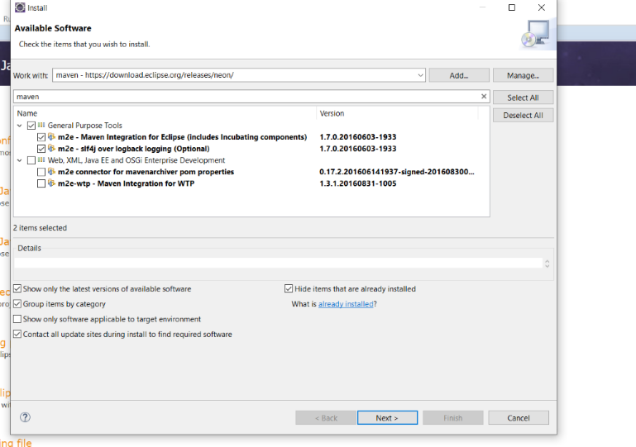

* 1. **Part 2: Install the Eclipse Checkstyle plug-in**

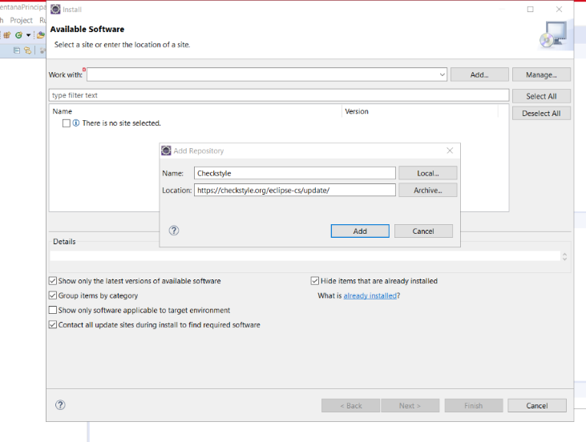

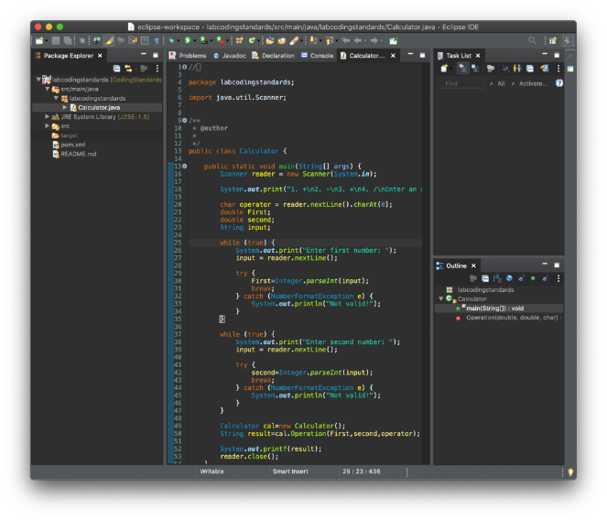

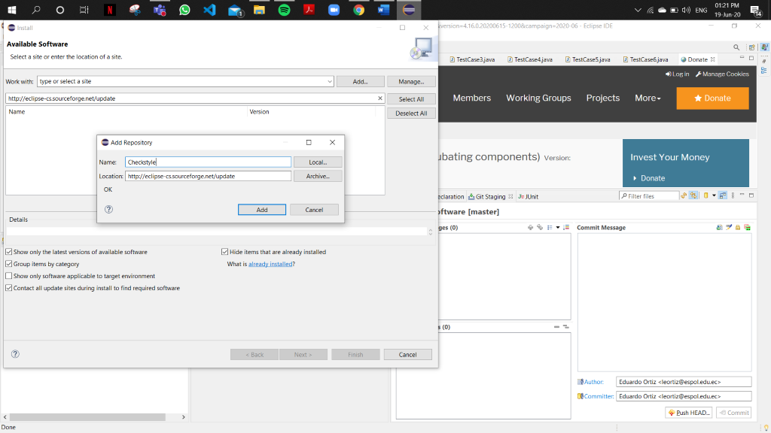

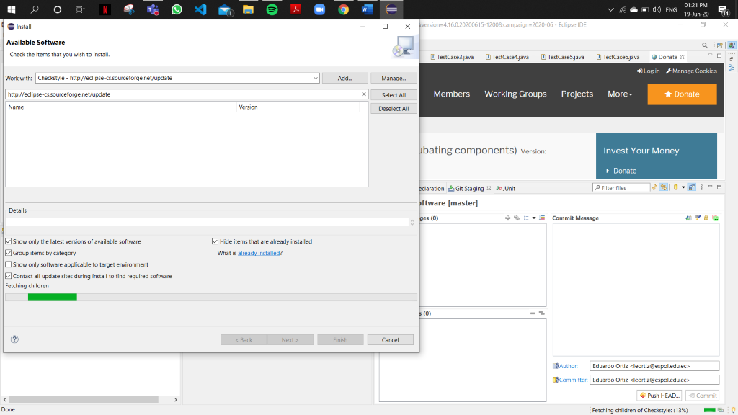

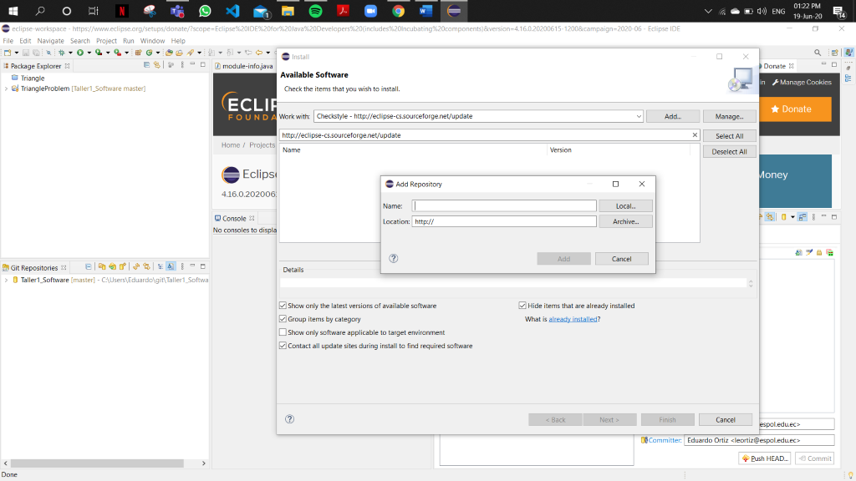

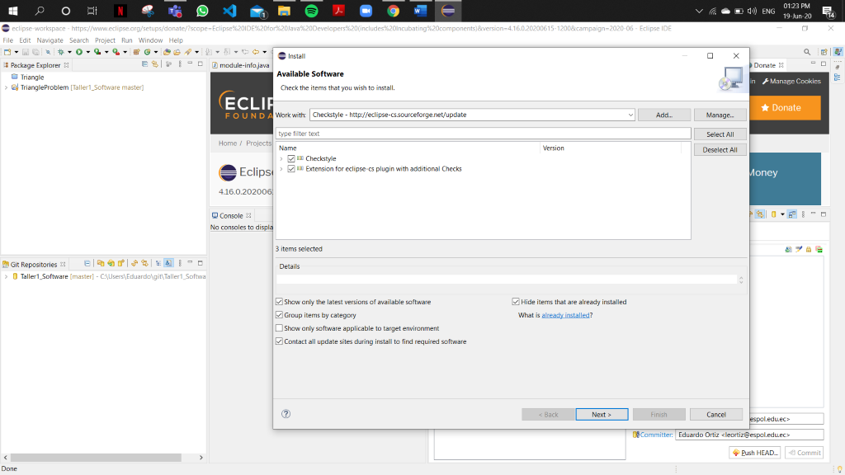

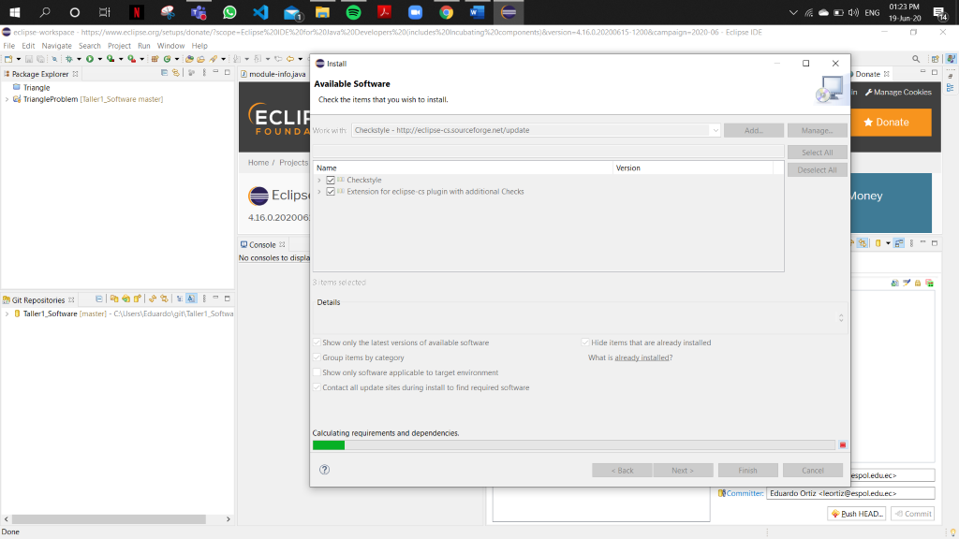

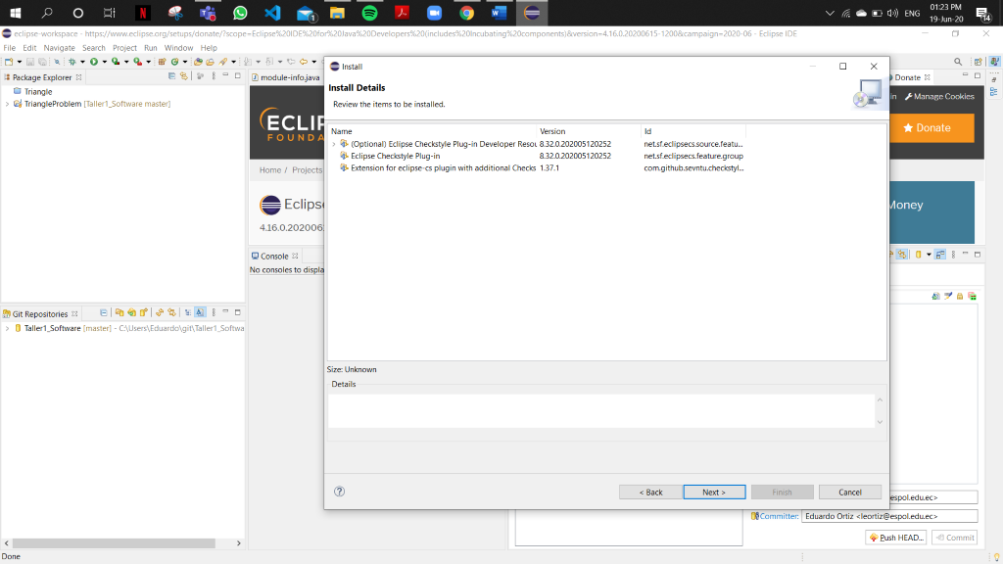

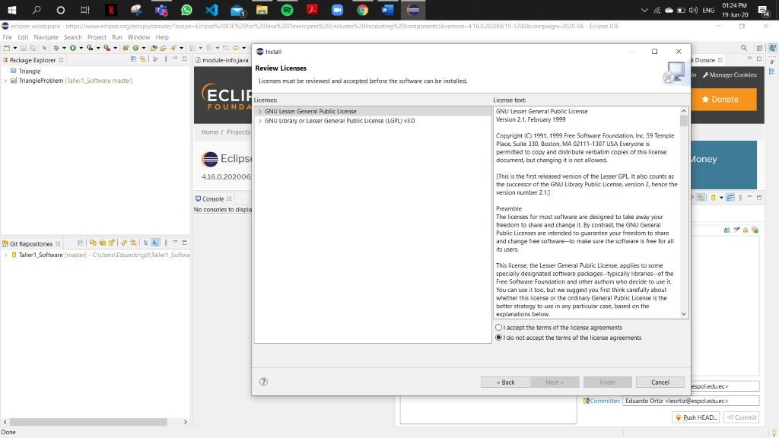

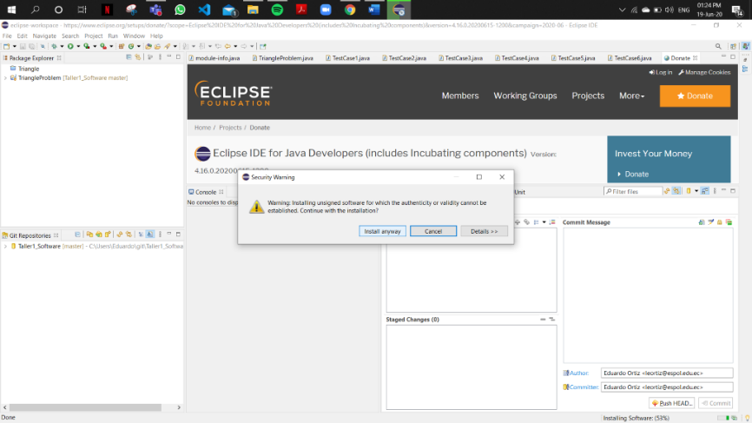

* 1. **Implementation**

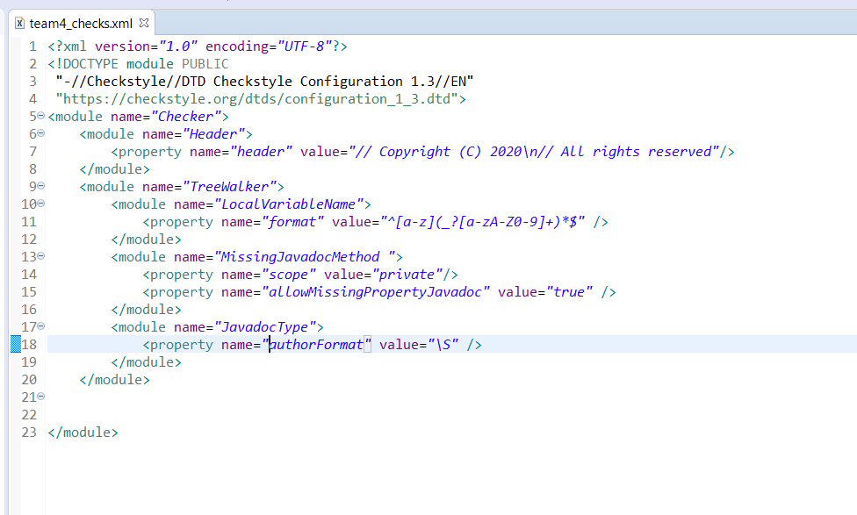

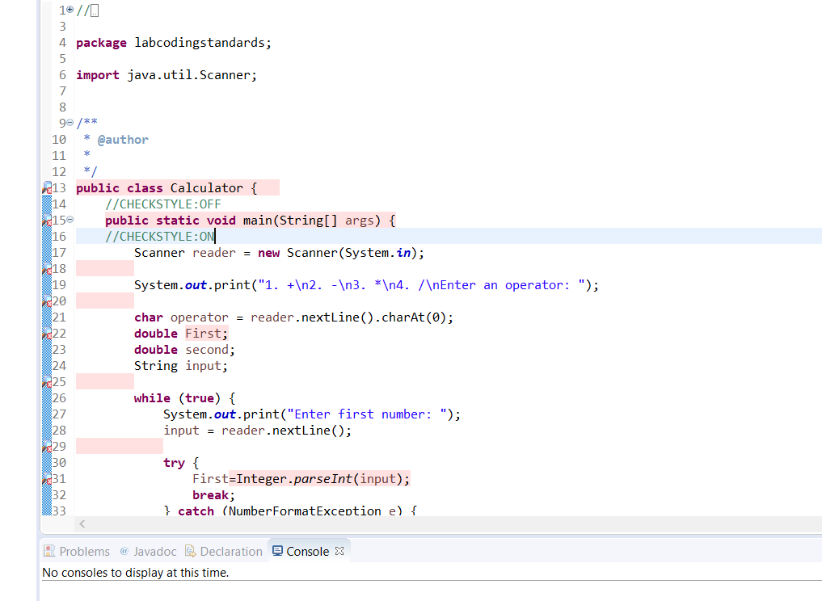

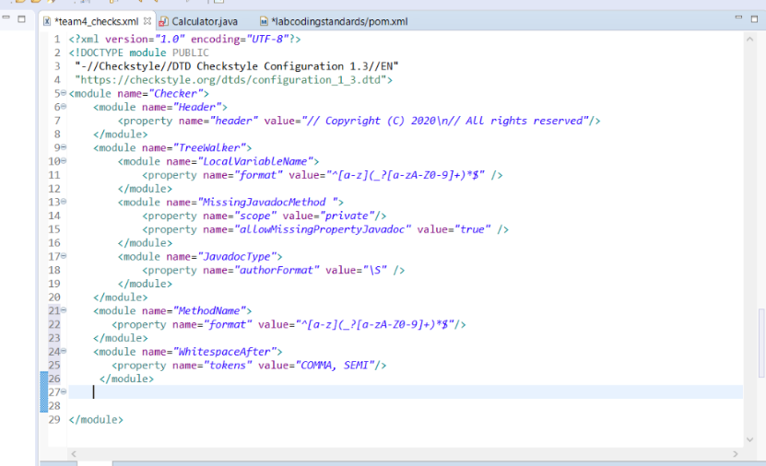

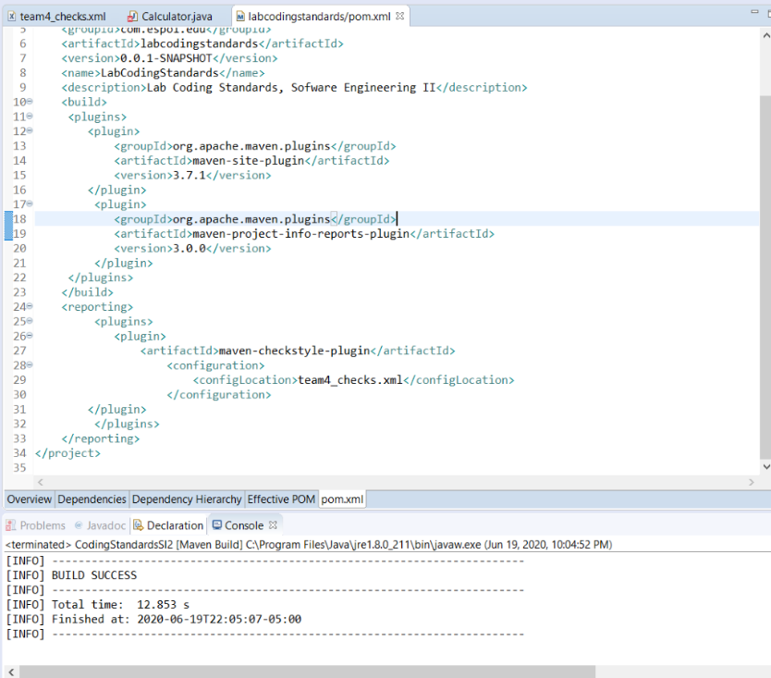

1. **Conclusions**

* This plug-in is a usefull tool to the implementation.
* Checklist improve the process of error identification.
* In case of reboot of eclipse the checklist should be activated again.